**Transfer Bookmarks (Google Chrome, Microsoft Edge, Mozilla Firefox)**

Bookmarks are generally transferred when users are switching from one computer to another computer or switching from one browser to another browser. So, it is possible to transfer bookmarks of google chrome to firefox and vice-versa. On the other hand it is also possible to transfer bookmarks to the same browser and it is done when switching to a new computer. So, in this article you’ll be only learning how to transfer bookmarks from one browser to another browser as the processes are the same when transferring bookmarks to a new computer.

**Method 1: Microsoft Edge to Google Chrome**

Using this method you can transfer bookmarks from Microsoft Edge to Google chrome easily.



**Step1:** Go to your Microsoft edge browser and click on the three dots and select **favorites.**

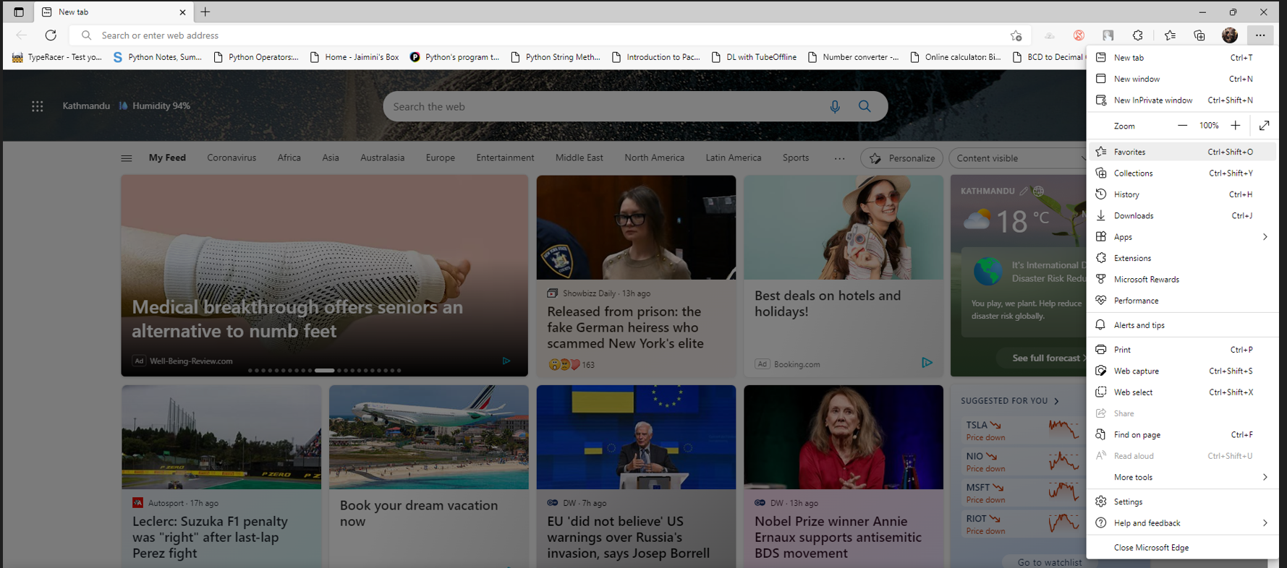

**Step 2:** Here, click on more options and select **Export favorites** to convert your bookmarks to html. 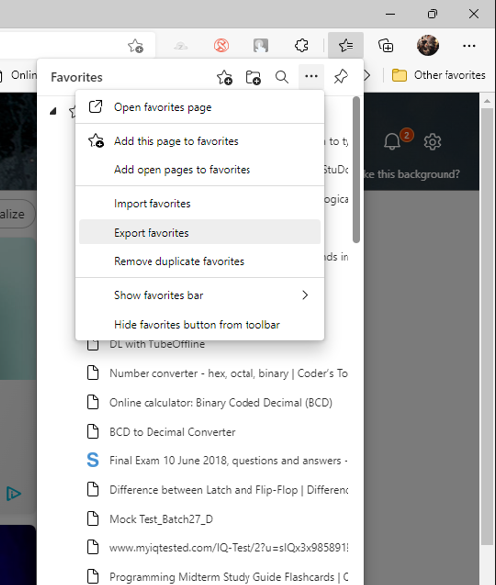

**Step 3:** Rename the file as it will be easier to locate the file later and save the html file in your favorite destination.

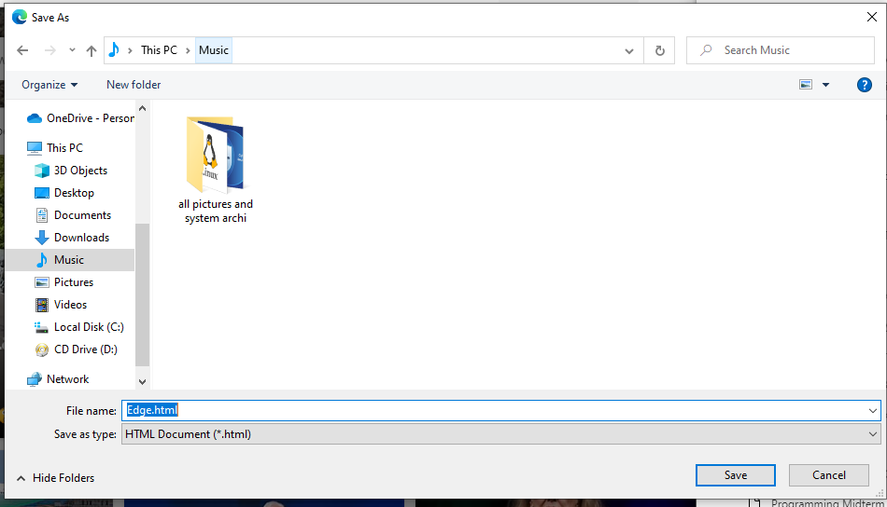

**Step 4:** Open up your google chrome browser to import the file exported through Microsoft edge. To do that go to the three dots menu in google chrome.

Then, **Bookmarks >Bookmark manager.**

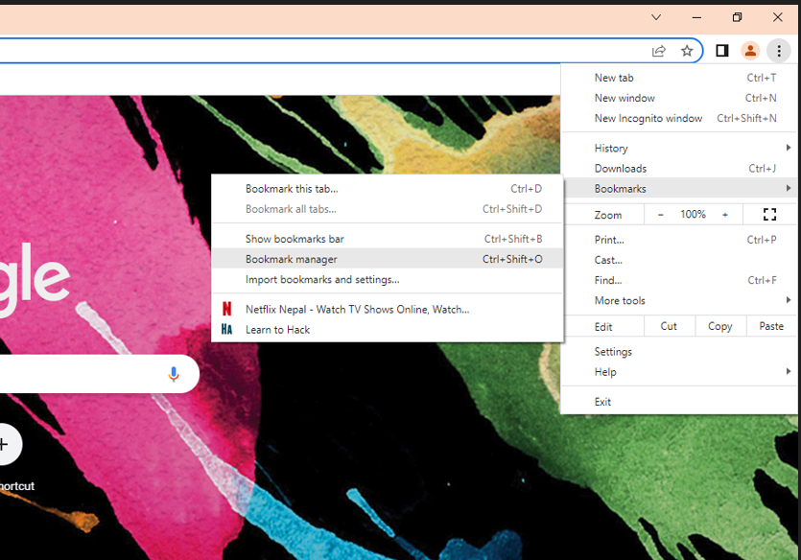

**Step 5:** As you can see there are only two bookmarks in google chrome. To get the bookmarks from Microsoft Edge go to the three dots menu and click import bookmarks.

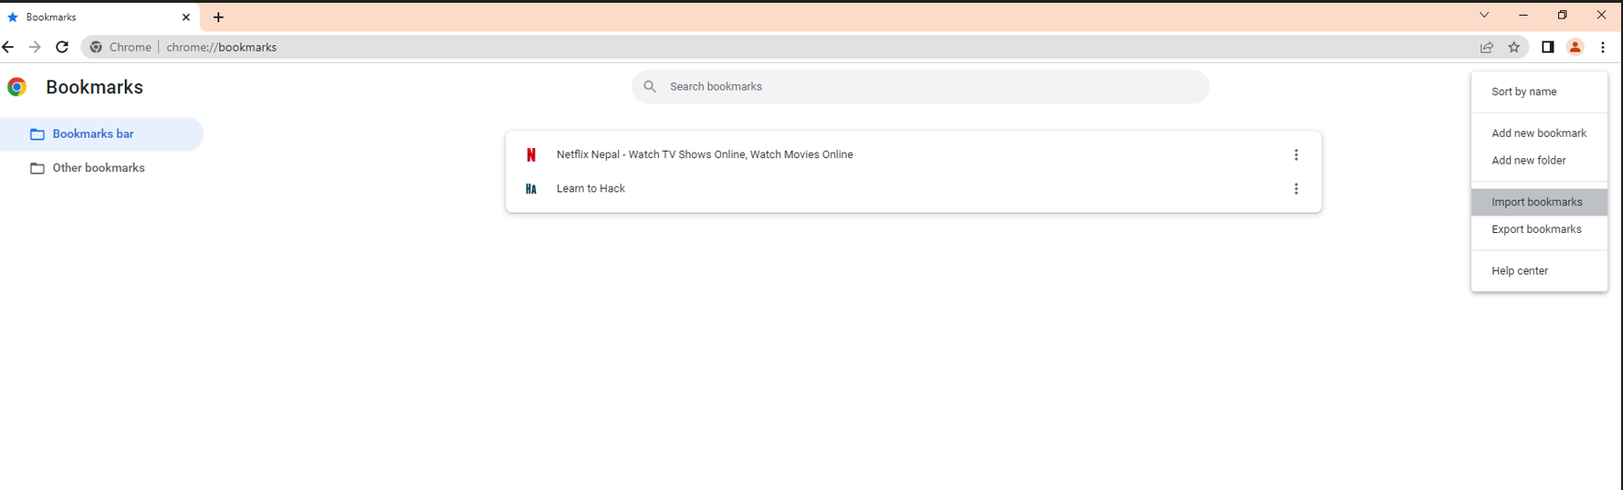

**Step 6:** locate the bookmarks that you saved previously and hit open. 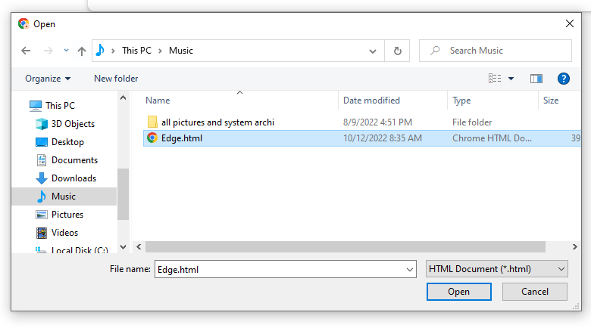

After doing so, all the bookmarks will be imported successfully.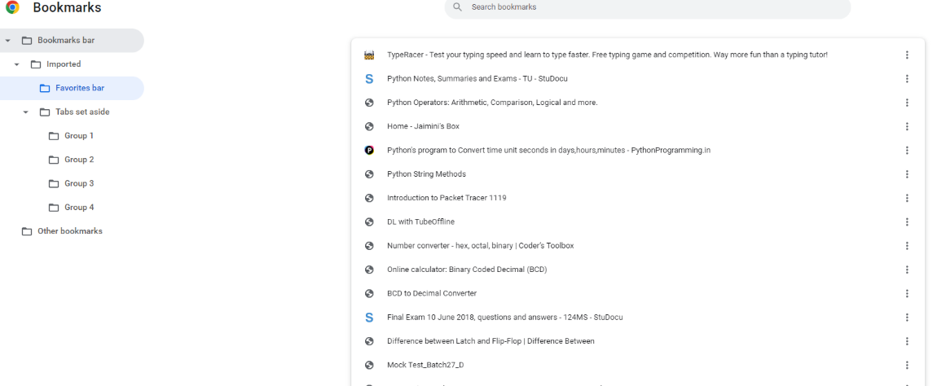

**Method 2: Google Chrome to Mozilla Firefox**

Using this method you can transfer bookmarks from Google chrome to Mozilla Firefox easily.

**Step 1:** Open up your google chrome browser and click on the three dots menu.

Then, **Bookmarks>Bookmark manager**

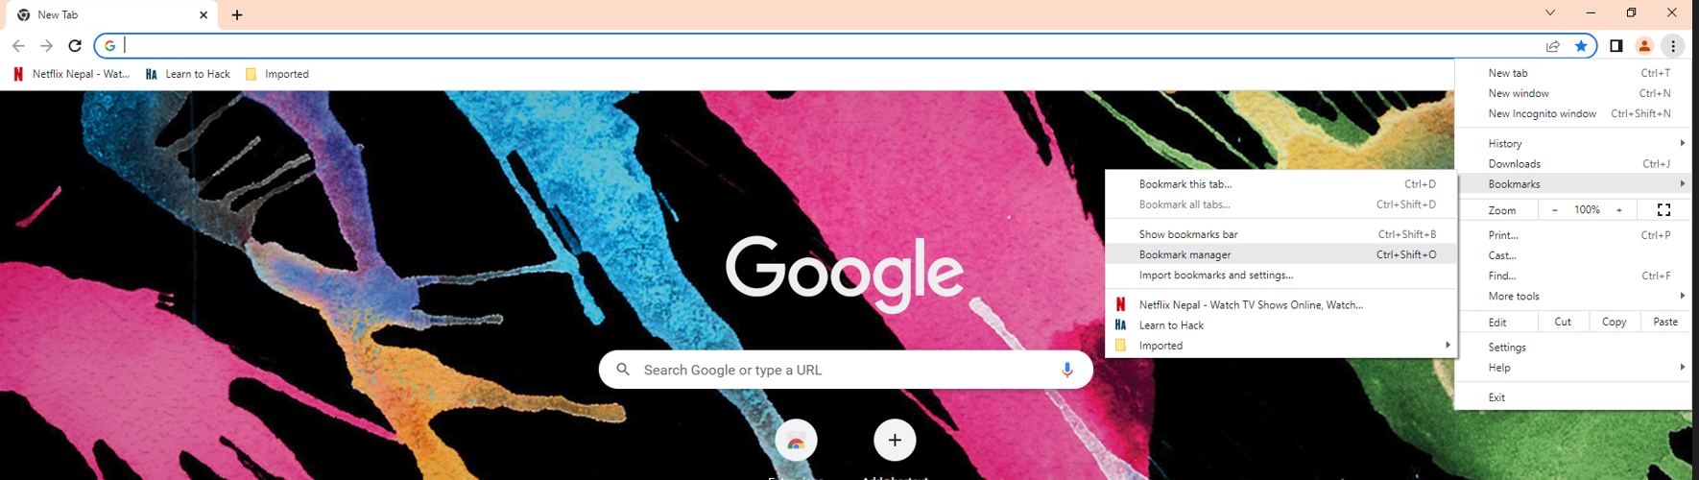

**Step 2:** In the new window pop up click on organize (three dots) and click on export bookmarks.

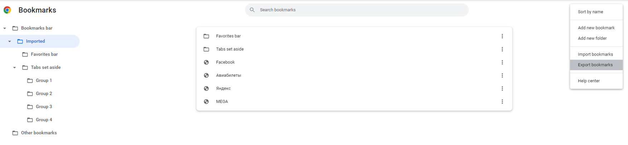

**Step 3:** Rename the file as it will be easier to locate the file later and save the html file in your favorite destination. I have renamed the file as “**Chrome”**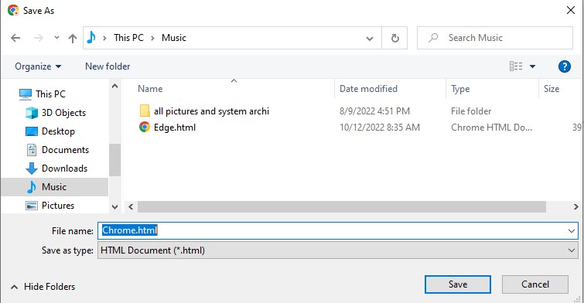

**Step 4:** Fire up your Firefox browser and select Bookmarks from three horizontal bars.

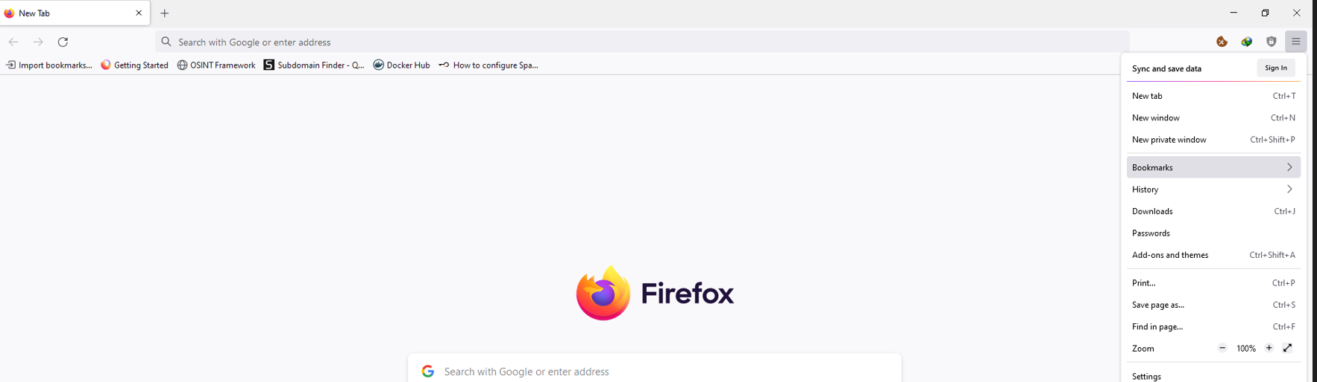

**Step 5:** In the new window pop up click on Manage bookmarks.

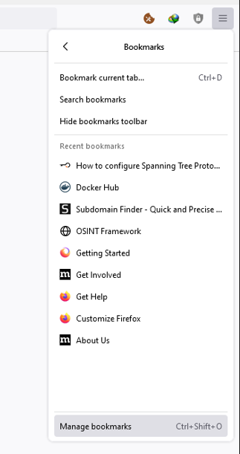

**Step 6**: In the new window pop up. Go to **Import and Backup>Import Bookmarks from HTML.**

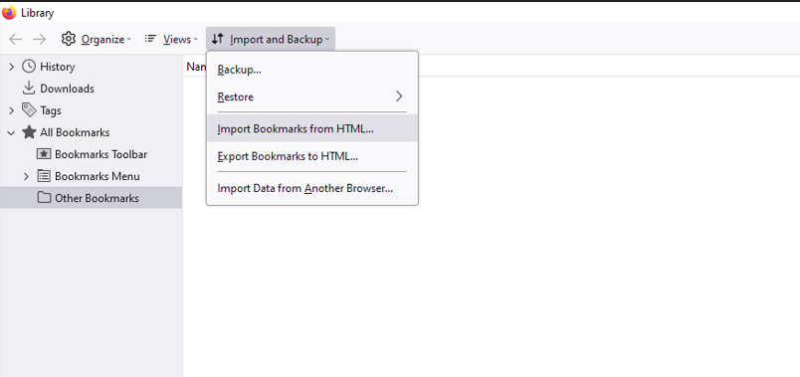

**Step 7:** locate the bookmarks that you saved previously (Chrome) and hit open and the bookmarks will be successfully imported.

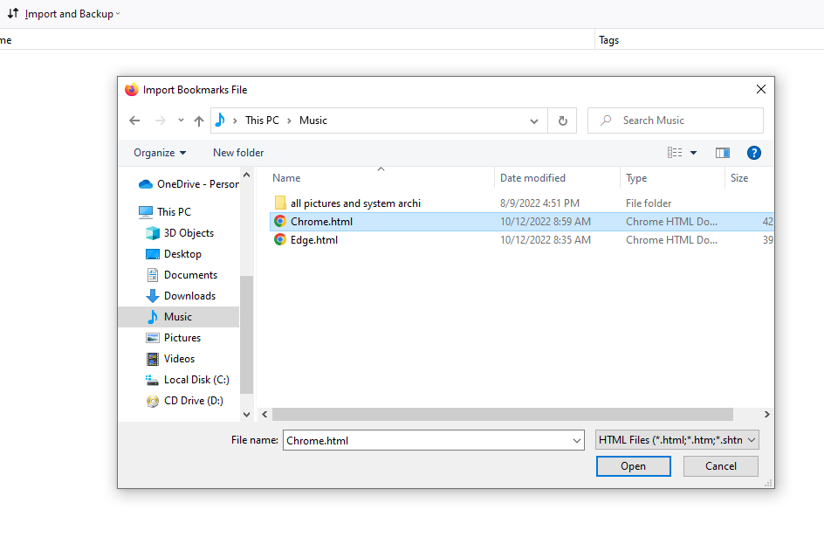

**Method 3: Mozilla Firefox to Microsoft edge**

Using this method you can transfer bookmarks from Mozilla Firefox to Microsoft Edge easily.

**Step 1:** Fire up your Firefox browser and select Bookmarks from three horizontal bars.



**Step 2:** In the new window pop up click on Manage bookmarks.

**Step 3:** Step 6: In the new window pop up. Go to **Import and Backup>Export Bookmarks to HTML**.

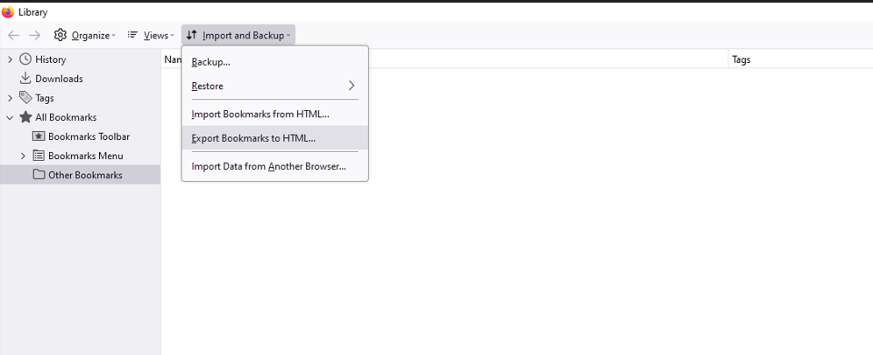

**Step 4:** Rename the file as it will be easier to locate the file later and save the html file in your favorite destination. I have renamed the file as “firefox”.

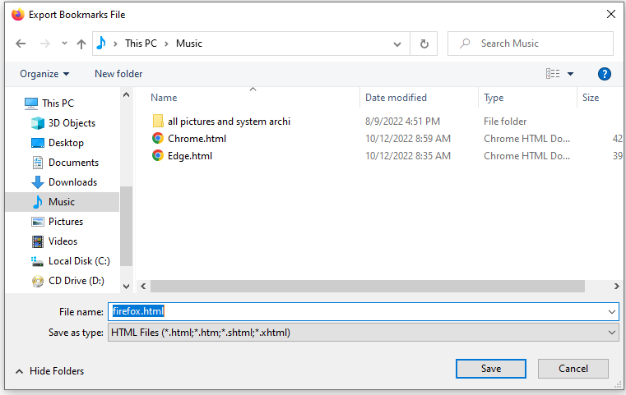

**Step 5:** Go to your Microsoft edge browser and click on the three dots and select favorites.



**Step 6:** After that select import favorites to import bookmarks from firefox.

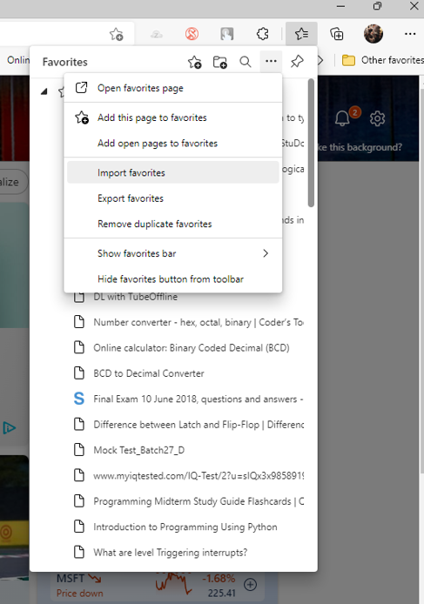

**Step 7:** If you don’t get a pop up then just click on import browser data.

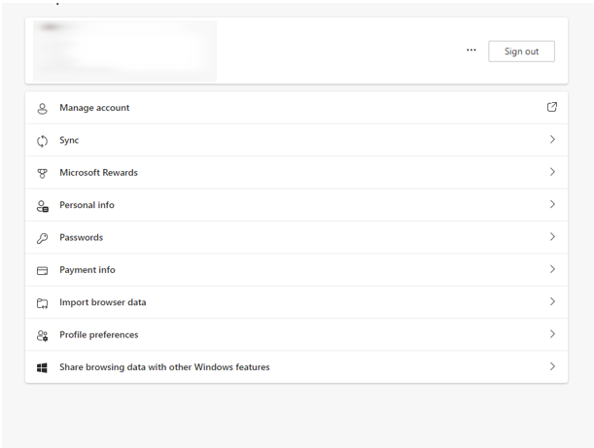

**Step 8:** In this new window. Select favorites or bookmarks HTML file as we are going to import bookmarks through HTML file.

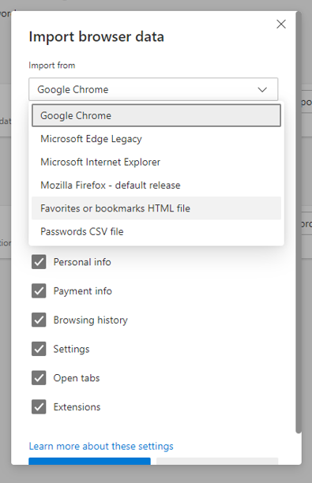

**Step 9:** Choose the html file to import the bookmarks. In our case it is firefox.

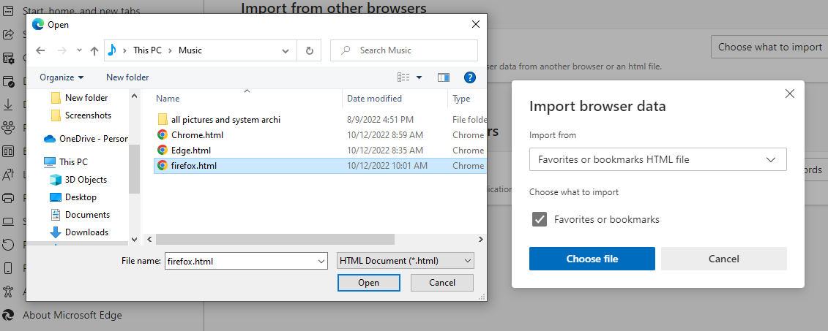

**Step 10:** After clicking done the data will be imported successfully from firefox to Microsoft edge.

